*TalkBox Configurator* User Manual

**T**alkbox is a highly customizable virtual lexigram interface that allows persons with speech disabilities to communicate. The configurator is rich with features to customize the appearance, functionality, feel of the audio buttons.

**1 Installation Instructions**

*Prerequisite:* **Java** must be installed. Click <here> to install.

To install the software, please visit the *Talkbox* project site at <https://github.com/Jakjm/Talkbox> and download and extract the zip folder. In the **Executables**folder, there are three core applications: The *Talkbox Configurator*, *Talkbox Simulator*, and *TBC Log*.

*Under the ‘Clone or download’ dropdown, click Download Zip.*

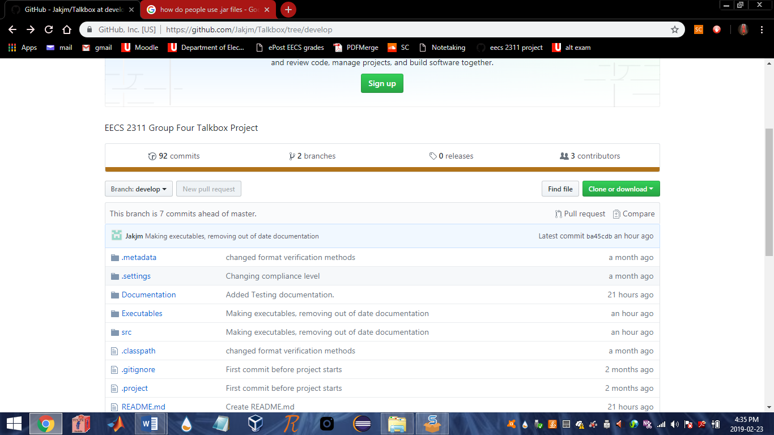

2 **Using the Configurator**

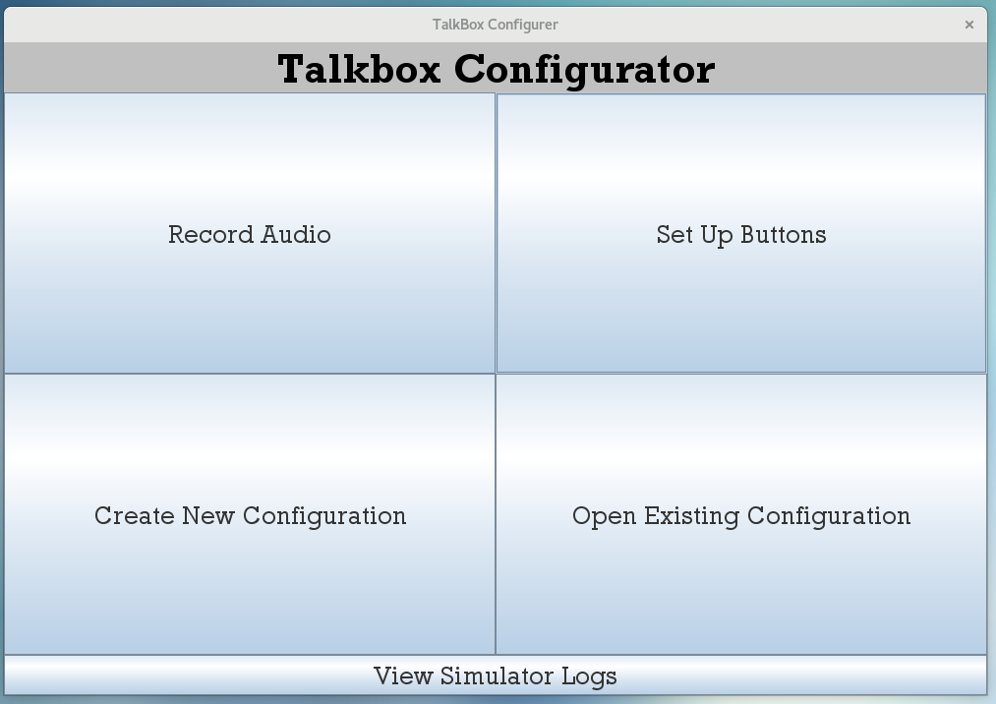*In this configuration menu there are five buttons.*

Record Audio—the purpose of this panel is to record phrases and words that can be used for the buttons. After recording, the user must put the save the audio file on their computer (but not the *Talkbox* directory— it will not recognize it). Alternatively, these sounds can be recorded within the *Set Up Buttons* panel.

The user can name the audio file to whatever they want. At this time only *WAVE* files can be used. To record audio, press *Record*. This is now the time to record anything that the user would like to record. When finished recording the user must press *Stop Recording.* After selecting *Stop Recording,* select a directory to save the recording in. When “OK” is selected, a window with a list of directories will pop up. The user should select where they would like to save the recording. This recording can then be played back when associated to a button. The below figure shows a screenshot of the audio recording panel.

*This is what the Recording audio panel looks like when selected*

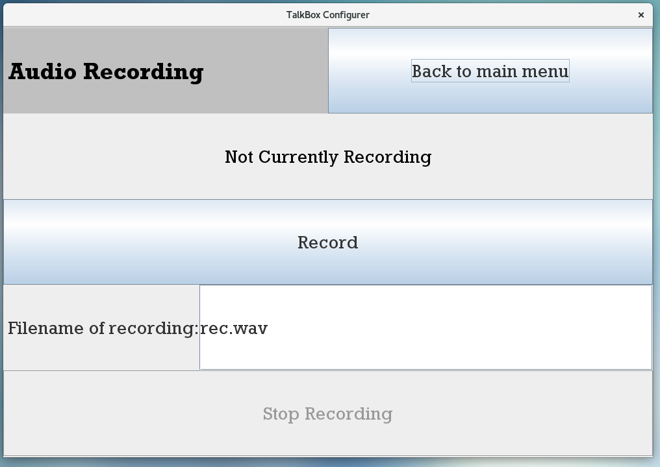

*When OK, the user must save the audio file in a directory of their choice*

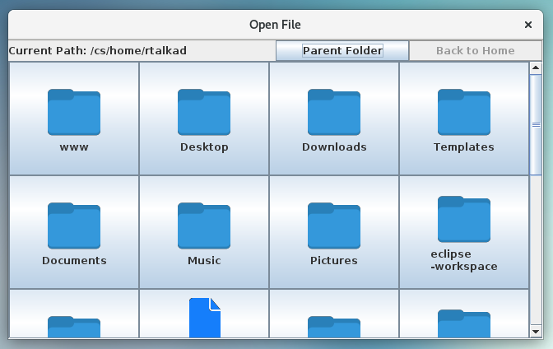

The Create New Configurationbutton allows the user create a new *TalkboxData* directory. New users should click this. The Open Existing Configuration allows the user to select an existing *TalkboxData* configuration director to allow further editing and customization.

The Set Up Buttons panel is not available until the user selects an existing *TalkboxData* directory or makes a new configuration directory. This is where one can setup the orientation of their buttons and can add or remove additional rows of buttons as one sees fit. In this panel the user can setup which audio clip goes to which button. They can use emojis, i.e. smile (☺) to allow the buttons to be more descriptive. The user can also name the button, change its color, or even add an image. When doing all these edits to the button, to ensure that this will be saved the user MUST press C*onfirm Setup*.

*All five buttons fully lit up.*

By default, there are six buttons, but the user can add as many buttons as they want through the “addition” of rows. The user can also delete rows that are not needed or not to their liking. In this panel the user can also record audio and add it straight to a button. Adding an image to the button is also a feature which is very user friendly. The user can select the orientation of the image (square, vertical or horizontal).

*Visual of the setup prompt for each button.*

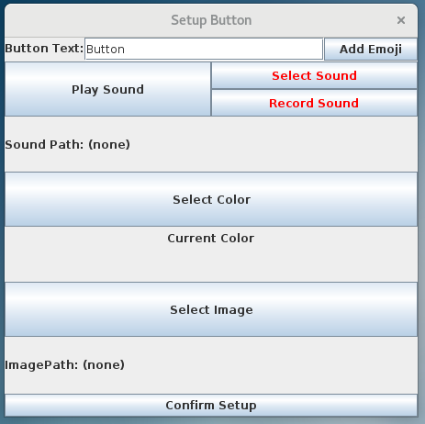

*This is the emoji panel. They can be dynamically added to buttons if one want to change its expression.*

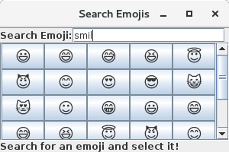

*Of course, the user can change the button color as they see fit.*

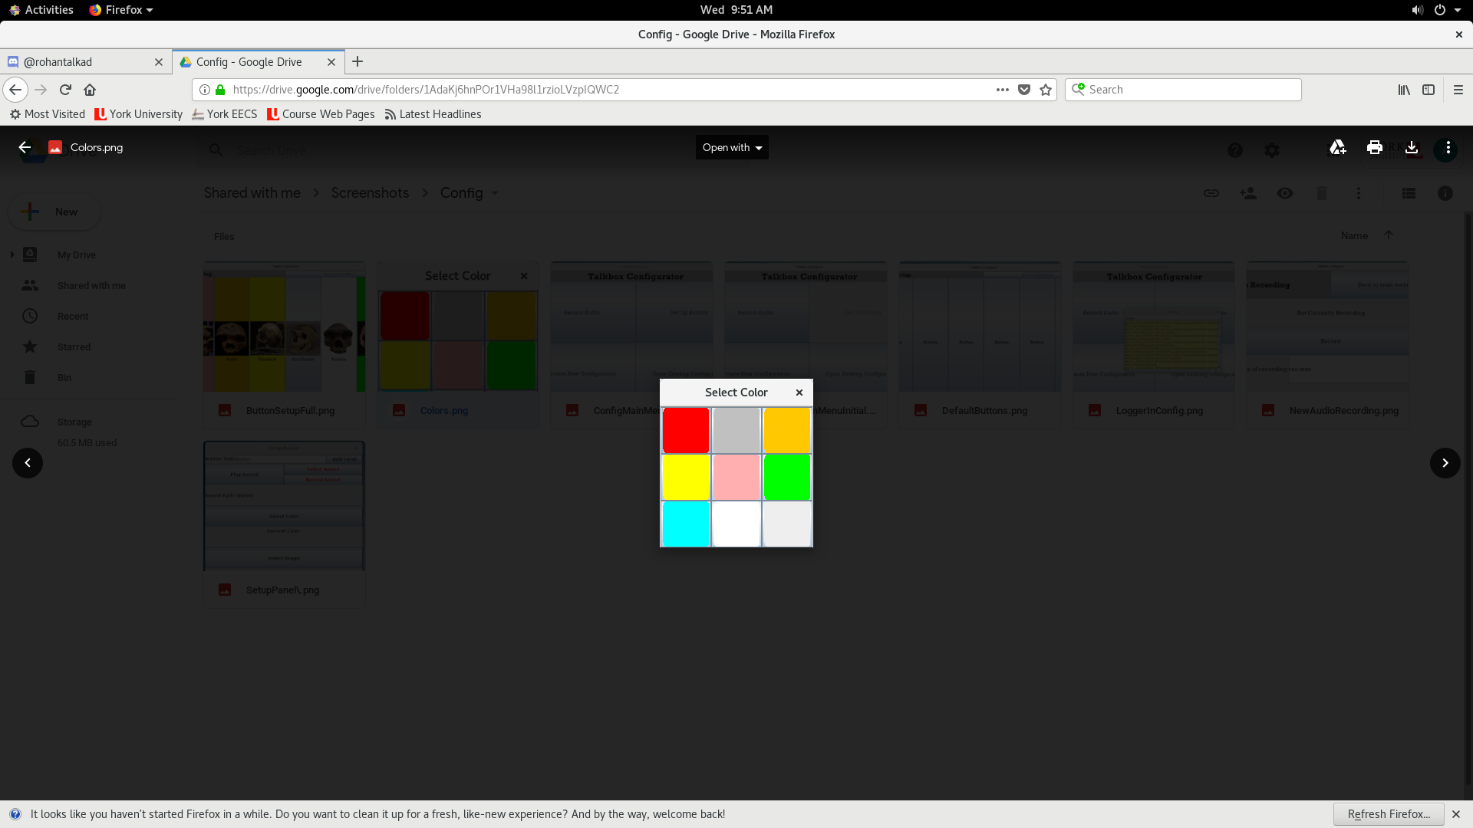

*The complete panel with a sample selection of images, sounds, and colors.*

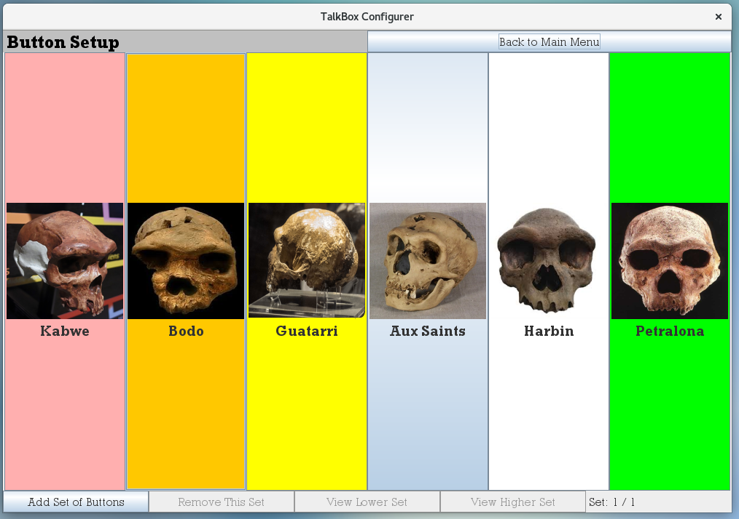

**3 Viewing the Simulator Logs**

Perhaps you, as a caregiver, are interested in the use of the simulator and whether certain buttons are being used. Maybe, there need to be different buttons for the same phrase. We record a every single user action, and this is available for your optimization. Go back to the Main Menu and hit View Simulator Logs. All the logs will be shown with their timestamps. Note that you can export and delete the logs as you see fit. Please refer to the TBC Log User Manual for the details on this usage.

